**CN Lab**

**Session 4 – (17/12/2020)**

Parthivi Choubey CSE – B - 5th semester

180905456 Roll. no. - 60

**Question 1 (7.4)**

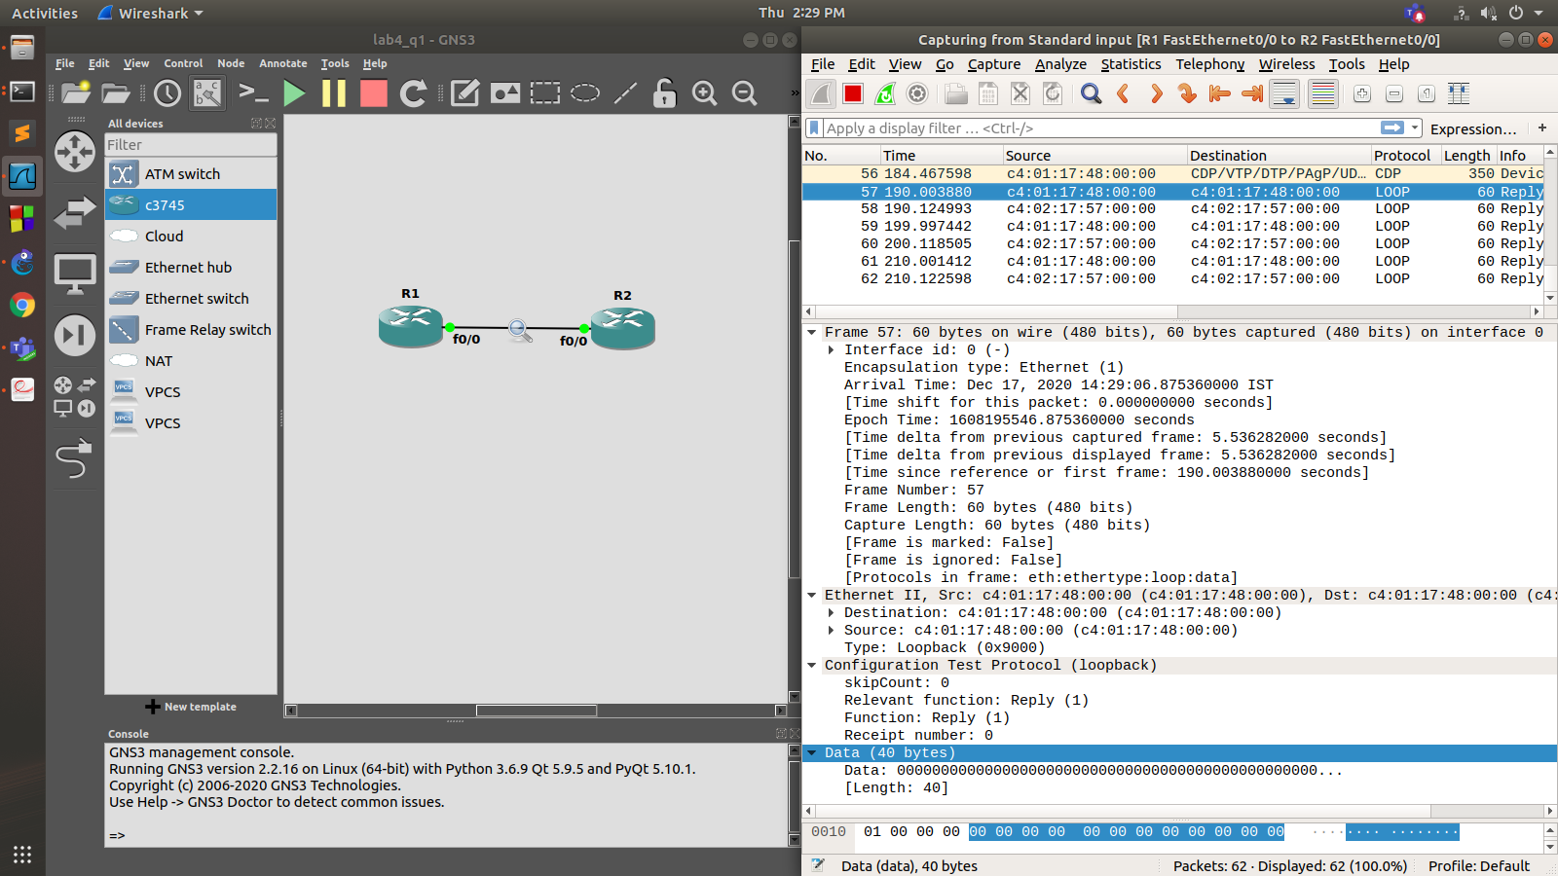

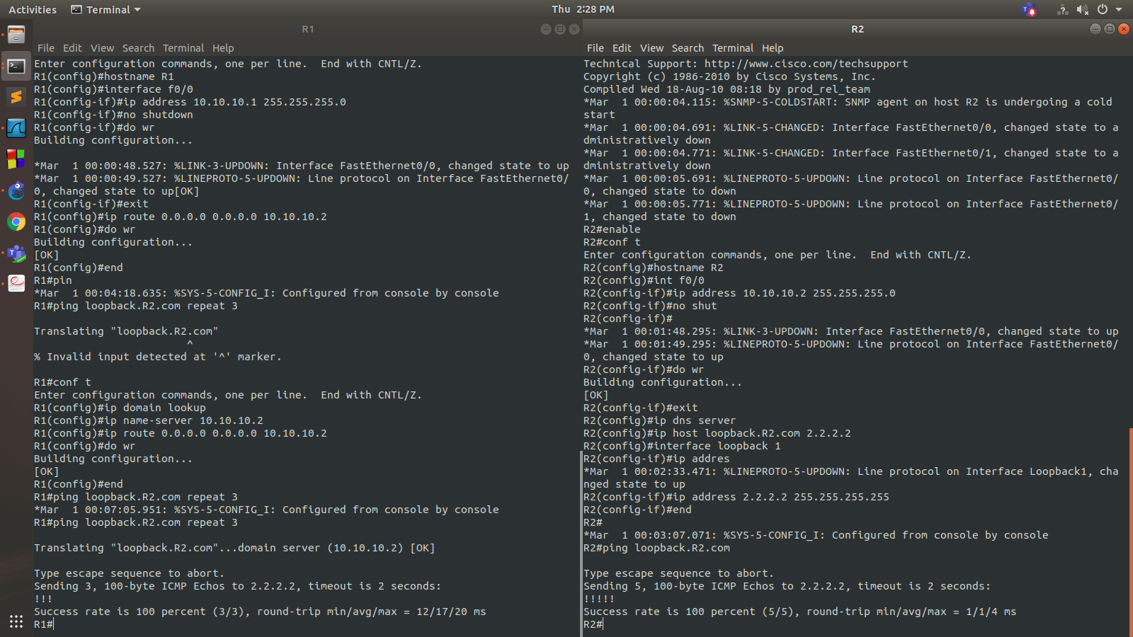

**R1**

R1#enable

R1#conf t

Enter configuration commands, one per line. End with CNTL/Z.

R1(config)#hostname R1

R1(config)#interface f0/0

R1(config-if)#ip address 10.10.10.1 255.255.255.0

R1(config-if)#no shutdown

R1(config-if)#do wr

Building configuration...

*Mar 1 00:00:48.527: %LINK-3-UPDOWN: Interface FastEthernet0/0, changed state to up

*Mar 1 00:00:49.527: %LINEPROTO-5-UPDOWN: Line protocol on Interface FastEthernet0/0, changed state to up[OK]

R1(config-if)#exit

R1(config)#

**R2**

R2#enable

R2#conf t

Enter configuration commands, one per line. End with CNTL/Z.

R2(config)#hostname R2

R2(config)#int f0/0

R2(config-if)#ip address 10.10.10.2 255.255.255.0

R2(config-if)#no shut

R2(config-if)#

*Mar 1 00:01:48.295: %LINK-3-UPDOWN: Interface FastEthernet0/0, changed state to up

*Mar 1 00:01:49.295: %LINEPROTO-5-UPDOWN: Line protocol on Interface FastEthernet0/0, changed state to up

R2(config-if)#do wr

Building configuration...

[OK]

R2(config-if)#exit

R2(config)#ip dns server

R2(config)#ip host loopback.R2.com 2.2.2.2

R2(config)#interface loopback 1

R2(config-if)#

*Mar 1 00:02:33.471: %LINEPROTO-5-UPDOWN: Line protocol on Interface Loopback1, changed state to up

R2(config-if)#ip address 2.2.2.2 255.255.255.255

R2(config-if)#end

R2#

*Mar 1 00:03:07.071: %SYS-5-CONFIG_I: Configured from console by console

R2#ping loopback.R2.com

Type escape sequence to abort.

Sending 5, 100-byte ICMP Echos to 2.2.2.2, timeout is 2 seconds:

!!!!!

Success rate is 100 percent (5/5), round-trip min/avg/max = 1/1/4 ms

R2#

**R1**

R1(config)#ip domain lookup

R1(config)#ip name-server 10.10.10.2

R1(config)#ip route 0.0.0.0 0.0.0.0 10.10.10.2

R1(config)#do wr

Building configuration...

[OK]

R1(config)#end

R1#ping loopback.R2.com repeat 3

*Mar 1 00:07:05.951: %SYS-5-CONFIG_I: Configured from console by console

R1#ping loopback.R2.com repeat 3

Translating "loopback.R2.com"...domain server (10.10.10.2) [OK]

Type escape sequence to abort.

Sending 3, 100-byte ICMP Echos to 2.2.2.2, timeout is 2 seconds:

!!!

Success rate is 100 percent (3/3), round-trip min/avg/max = 12/17/20 ms

R1#

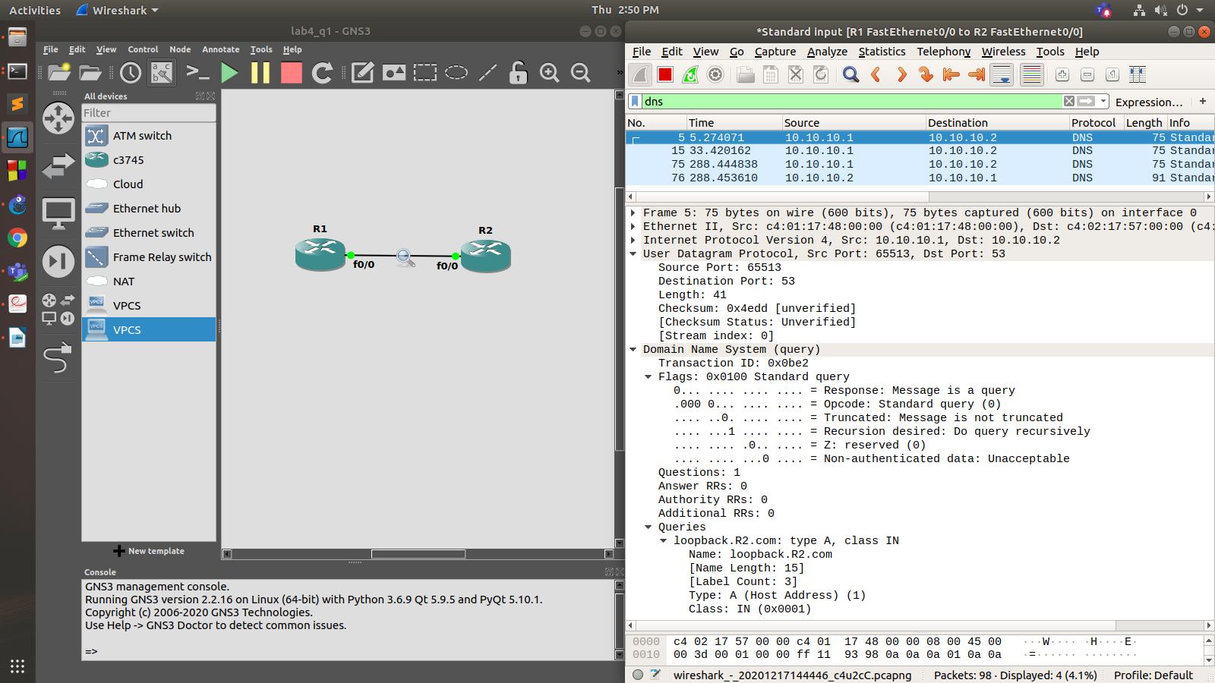

**Question 2**

**R1**

R1#enable

R1#conf t

Enter configuration commands, one per line. End with CNTL/Z.

R1(config)#int f0/0

R1(config-if)#ip add 40.40.40.2 255.255.255.0

R1(config-if)#no shut

R1(config-if)#

*Mar 1 00:03:22.299: %LINK-3-UPDOWN: Interface FastEthernet0/0, changed state to up

*Mar 1 00:03:23.299: %LINEPROTO-5-UPDOWN: Line protocol on Interface FastEthernet0/0, changed state to up

R1(config-if)#do wr

Building configuration...

[OK]

R1(config-if)#exit

R1(config)#ip dns server

R1(config)#ip host loopback.R2.com 2.2.2.2

R1(config)#interface loopback 1

R1(config-if)#

*Mar 1 00:04:15.099: %LINEPROTO-5-UPDOWN: Line protocol on Interface Loopback1, changed state to up

R1(config-if)#ip address 2.2.2.2 255.255.255.255

R1(config-if)#end

R1#

*Mar 1 00:04:30.291: %SYS-5-CONFIG_I: Configured from console by console

R1#write

Building configuration...

[OK]

R1#ping loopback.R2.com

Type escape sequence to abort.

Sending 5, 100-byte ICMP Echos to 2.2.2.2, timeout is 2 seconds:

!!!!!

Success rate is 100 percent (5/5), round-trip min/avg/max = 1/2/4 ms

R1#

**R2**

R2#enable

R2#config t

Enter configuration commands, one per line. End with CNTL/Z.

R2(config)#interface f1/0

R2(config-if)#ip address 40.40.40.1 255.255.255.0

R2(config-if)#no shutdown

R2(config-if)#

*Mar 1 00:01:24.975: %LINK-3-UPDOWN: Interface FastEthernet1/0, changed state to up

*Mar 1 00:01:25.975: %LINEPROTO-5-UPDOWN: Line protocol on Interface FastEthernet1/0, changed state to up

R2(config-if)#exit

R2(config)#int f0/0

R2(config-if)#ip add 10.10.10.1 255.255.255.0

R2(config-if)#no shut

R2(config-if)#

*Mar 1 00:01:46.935: %LINK-3-UPDOWN: Interface FastEthernet0/0, changed state to up

*Mar 1 00:01:47.935: %LINEPROTO-5-UPDOWN: Line protocol on Interface FastEthernet0/0, changed state to up

R2(config-if)#exit

R2(config)#int f0/1

R2(config-if)#ip add 30.30.30.1 255.255.255.0

R2(config-if)#no shut

R2(config-if)#

*Mar 1 00:02:12.267: %LINK-3-UPDOWN: Interface FastEthernet0/1, changed state to up

*Mar 1 00:02:13.267: %LINEPROTO-5-UPDOWN: Line protocol on Interface FastEthernet0/1, changed state to up

R2(config-if)#exit

R2(config)#exit

R2#

*Mar 1 00:02:29.727: %SYS-5-CONFIG_I: Configured from console by console

R2#write

Building configuration...

[OK]

R2#conf t

Enter configuration commands, one per line. End with CNTL/Z.

R2(config)#ip domain lookup

R2(config)#ip name-server 40.40.40.2

R2(config)#ip route 0.0.0.0 0.0.0.0 40.40.40.2

R2(config)#end

R2#

*Mar 1 00:05:54.559: %SYS-5-CONFIG_I: Configured from console by console

R2#write

Building configuration...

[OK]

R2#ping loopback.R2.com repeat 3

Translating "loopback.R2.com"...domain server (40.40.40.2) [OK]

Type escape sequence to abort.

Sending 3, 100-byte ICMP Echos to 2.2.2.2, timeout is 2 seconds:

!!!

Success rate is 100 percent (3/3), round-trip min/avg/max = 12/17/20 ms

R2#

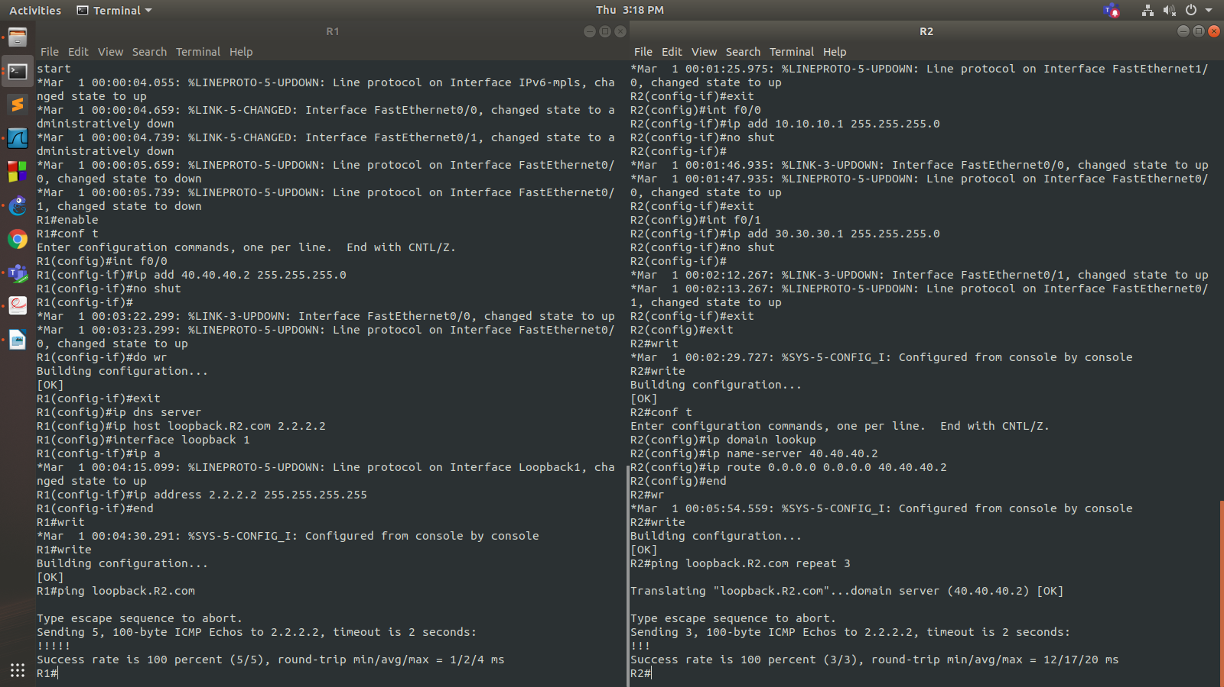

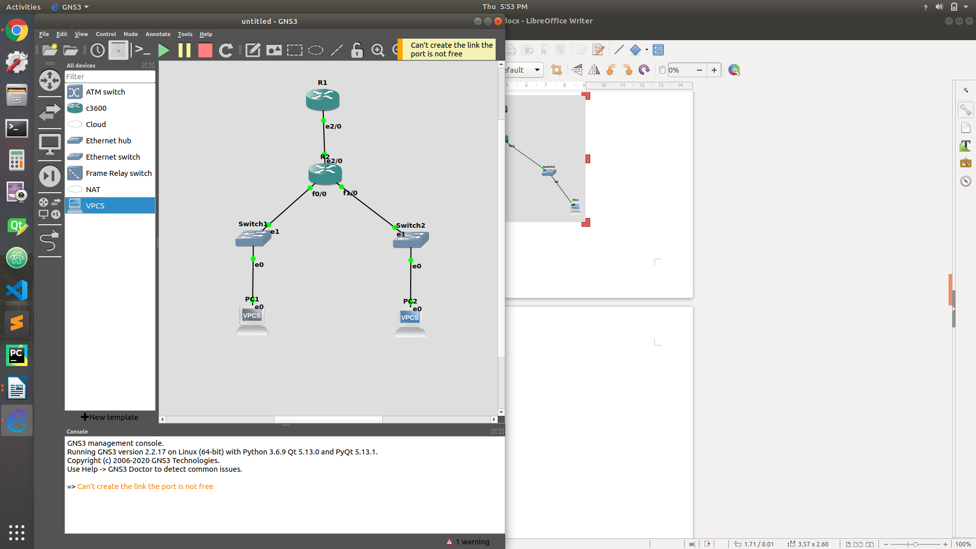

**Question 3**

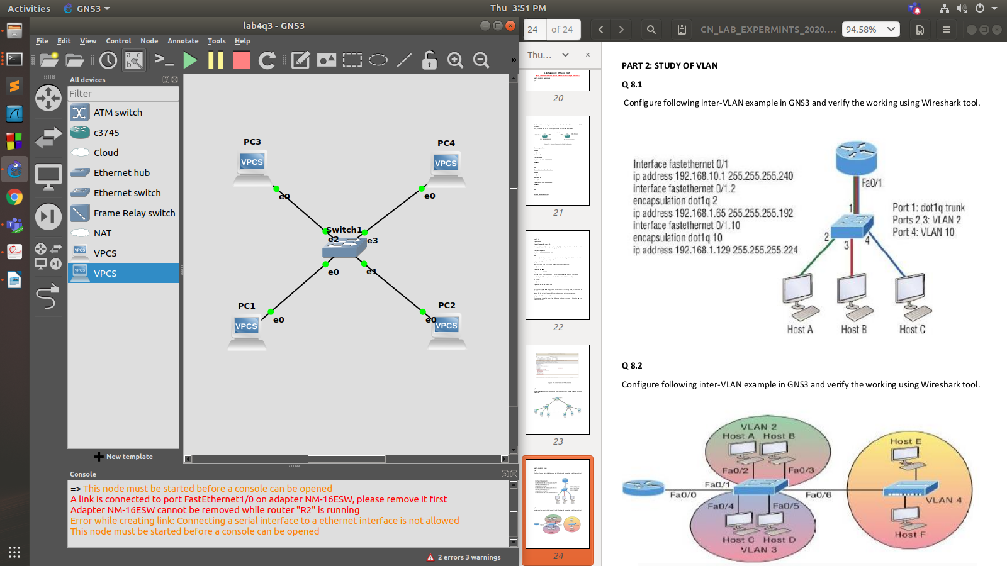

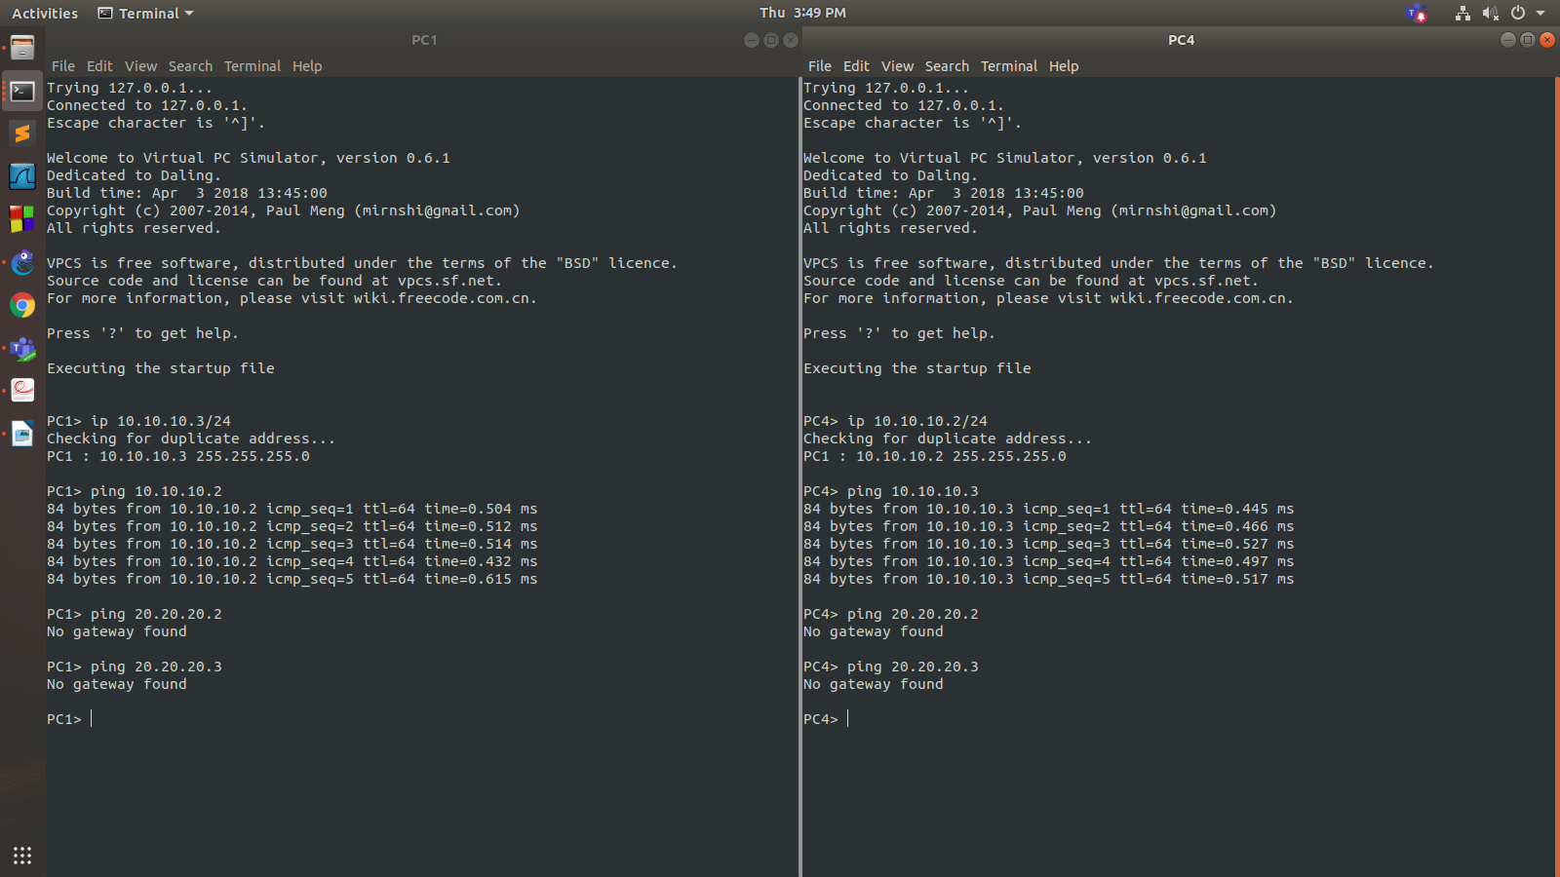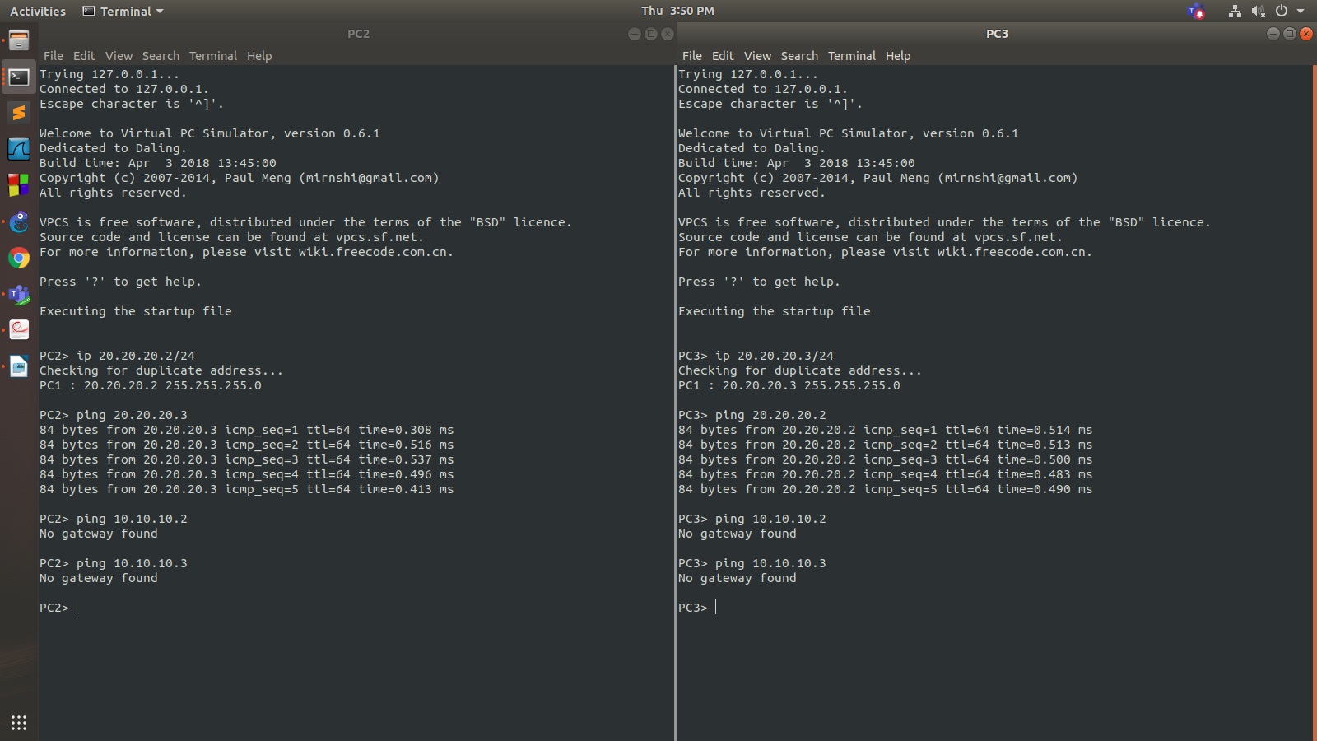

**Question 4 (8.1)**

**R1**

R1#enable

R1#conf t

Enter configuration commands, one per line. End with CNTL/Z.

R1(config)#interface f0/1

R1(config-if)#ip address 30.30.30.1 255.255.255.0

R1(config-if)#no shutdown

R1(config-if)#

*Mar 1 00:02:36.803: %LINK-3-UPDOWN: Interface FastEthernet0/1, changed state to up

*Mar 1 00:02:37.803: %LINEPROTO-5-UPDOWN: Line protocol on Interface FastEthernet0/1, changed state to up

R1(config-if)#exit

R1(config)#int f0/1.2

R1(config-subif)#encapsulation dot1q 2

R1(config-subif)#ip add 1

*Mar 1 00:05:47.287: %LINK-3-UPDOWN: Interface FastEthernet0/1, changed state to up

R1(config-subif)#ip add 10.10.10.1 255.255.255.0

R1(config-subif)#no shut

R1(config-subif)#exit

R1(config)#int f0/1.10

R1(config-subif)#encapsulation dot1q 10

R1(config-subif)#ip add 20.20.20.1 255.255.255.0

R1(config-subif)#no shut

R1(config-subif)#exit

R1(config)#end

R1#

*Mar 1 00:09:49.787: %SYS-5-CONFIG_I: Configured from console by console

R1#write

Building configuration...

[OK]

R1#

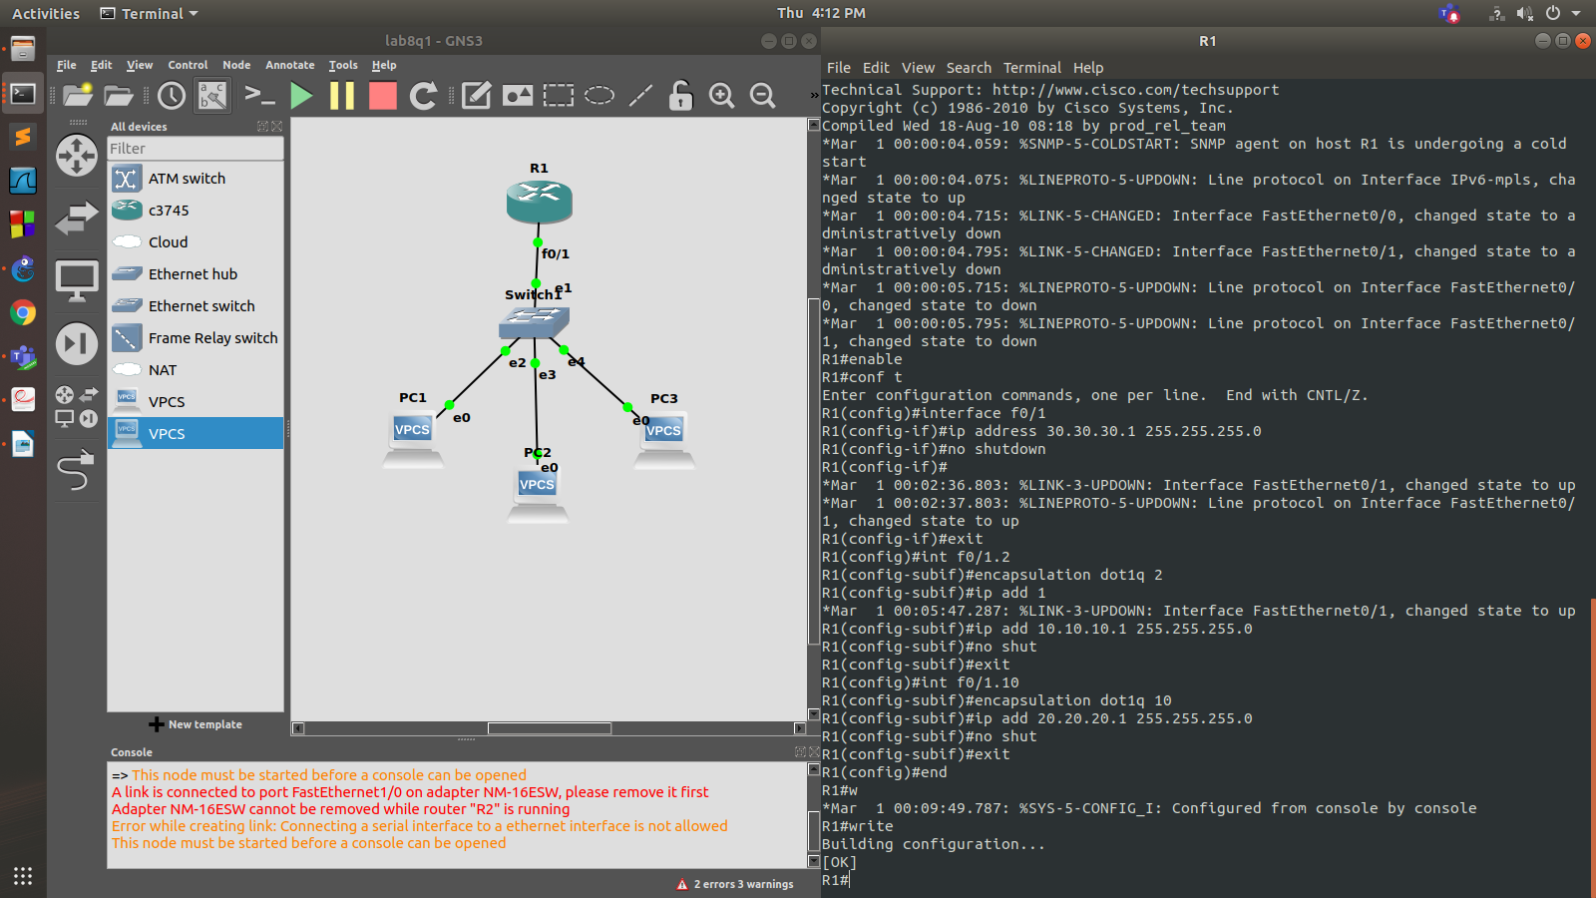

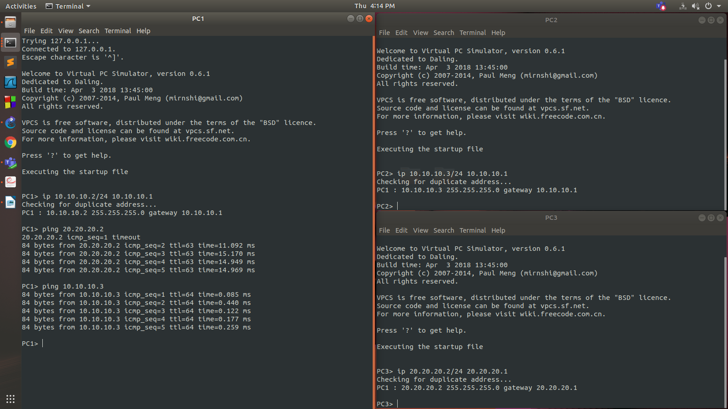

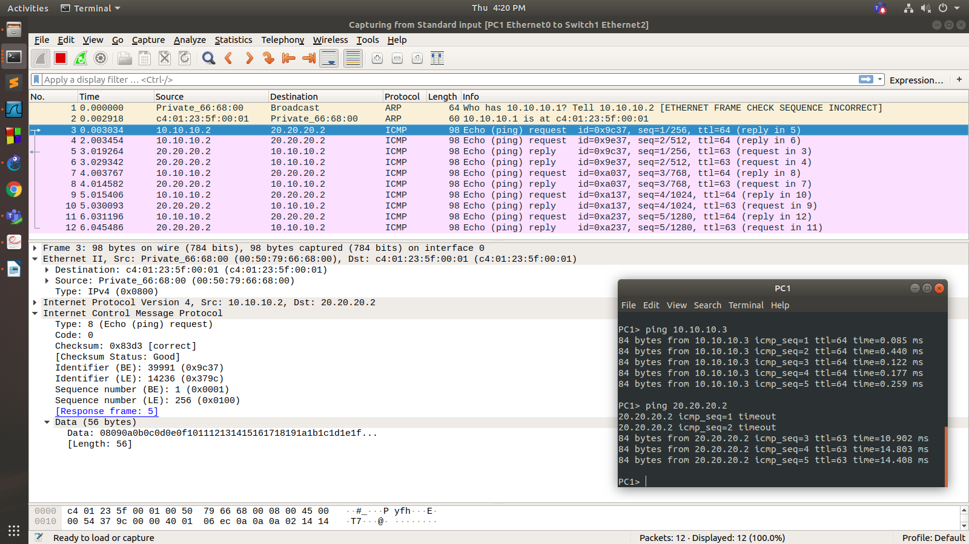

**PC1**

PC1> ip 10.10.10.2/24 10.10.10.1

Checking for duplicate address...

PC1 : 10.10.10.2 255.255.255.0 gateway 10.10.10.1

PC1> ping 20.20.20.2

20.20.20.2 icmp_seq=1 timeout

84 bytes from 20.20.20.2 icmp_seq=2 ttl=63 time=11.092 ms

84 bytes from 20.20.20.2 icmp_seq=3 ttl=63 time=15.170 ms

84 bytes from 20.20.20.2 icmp_seq=4 ttl=63 time=14.949 ms

84 bytes from 20.20.20.2 icmp_seq=5 ttl=63 time=14.969 ms

PC1> ping 10.10.10.3

84 bytes from 10.10.10.3 icmp_seq=1 ttl=64 time=0.085 ms

84 bytes from 10.10.10.3 icmp_seq=2 ttl=64 time=0.440 ms

84 bytes from 10.10.10.3 icmp_seq=3 ttl=64 time=0.122 ms

84 bytes from 10.10.10.3 icmp_seq=4 ttl=64 time=0.177 ms

84 bytes from 10.10.10.3 icmp_seq=5 ttl=64 time=0.259 ms

**PC2**

PC2> ip 10.10.10.3/24 10.10.10.1

Checking for duplicate address...

PC1 : 10.10.10.3 255.255.255.0 gateway 10.10.10.1

**PC3**

PC3> ip 20.20.20.2/24 20.20.20.1

Checking for duplicate address...

PC1 : 20.20.20.2 255.255.255.0 gateway 20.20.20.1

**Question 5 (8.2)**

**R1**

R1#enable

R1#conf t

Enter configuration commands, one per line. End with CNTL/Z.

R1(config)#int f0/0

R1(config-if)#ip address 30.30.30.1 255.255.255.0

R1(config-if)#no shut

R1(config-if)#

*Mar 1 00:00:40.811: %LINK-3-UPDOWN: Interface FastEthernet0/0, changed state to up

*Mar 1 00:00:41.811: %LINEPROTO-5-UPDOWN: Line protocol on Interface FastEthernet0/0, changed state to up

R1(config-if)#do wr

Building configuration...

[OK]

R1(config-if)#exit

R1(config)#int f0/0.1

R1(config-subif)#encapsulation dot1q 1

R1(config-subif)#

*Mar 1 00:01:10.523: %LINK-3-UPDOWN: Interface FastEthernet0/0, changed state to up

R1(config-subif)#ip address 10.10.10.1 255.255.255.0

R1(config-subif)#no shut

R1(config-subif)#exit

R1(config)#int f0/0.2

R1(config-subif)#encapsulation dot1q 2

R1(config-subif)#ip address 20.20.20.1 255.255.255.0

R1(config-subif)#no shut

R1(config-subif)#exit

R1(config)#exit

R1#

*Mar 1 00:02:08.619: %SYS-5-CONFIG_I: Configured from console by console

R1#write

Building configuration...

[OK]

R1#

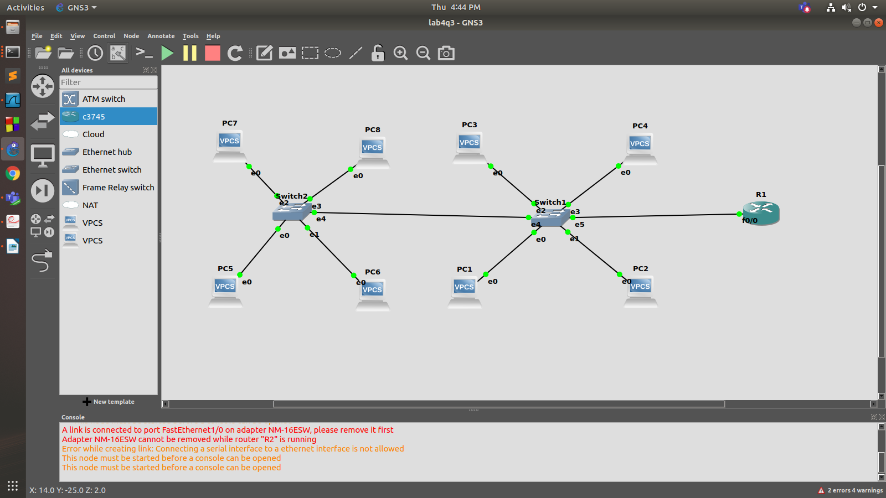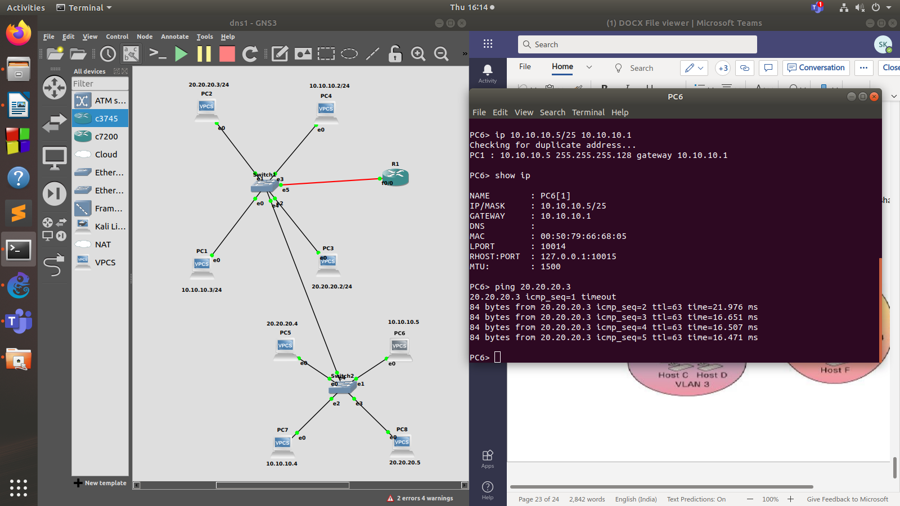

**Question 6 (7.5)**

